# Table of Contents

Table of Contents 1

Development Tool Versions 3

Subversion 3

Subversion Repository Location 3

Subversion Repository Structure 3

Robot 3

Dashboard 4

Docs 4

Branch Naming Convention 4

Robot Software Architecture 5

WPILibJ Template Type – Command-based Robot 5

Proper use of Subsystems and Commands 5

Subsystem List & Sensors 5

Command List with Descriptions 5

Global Variable List 5

Commenting with Javadoc Tags 6

Robot Software Design 8

Autonomous Command Sequences 8

Teleoperated Commands 8

Joystick Mappings 8

Tool Installation Process 8

Opening the Project in Netbeans 8

Opening the Project in Eclipse 8

Computer Setup to Deploy Software to cRIO 8

Linting Tools 9

Tool Execution 9

Code Acceptance Criteria 9

Automated Linting 9

# Development Tool Versions

|  |  |  |
| --- | --- | --- |
| **Tool Name** | **Version in Use** | **Stored at / Available From** |
| Subversion Server | 1.6.17 (r1128011) | <http://tortoisesvn.net/> |
| TortoiseSVN | 1.6.11 | <http://tortoisesvn.net/> |
| Java JDK | 1.6.0_38 | [http://www.oracle.com/](http://www.oracle.com/technetwork/java/javase/downloads/jdk7-downloads-1880260.html) |
| Netbeans | 7.2.1 | <https://netbeans.org/downloads/> |
| Eclipse | Galileo 1.2.1.20090918-0703 | <http://eclipse.org> |
| WPILibJ / Netbeans Plugins | 2013.0.589 | [http://first.wpi.edu/](http://first.wpi.edu/FRC/java/WPILibJ2014.0.zip) |
| WinMerge | 2.14.0.0 | <http://winmerge.org/> |
|  |  |  |

# Subversion

## Subversion Repository Location

Main Code: <http://nacsvn.aasd.k12.wi.us/repos/nac-software-2014>  
Subversion Training Code: <http://nacsvn.aasd.k12.wi.us/repos/training>

## Subversion Repository Structure

### Robot

Trunk

* Production Robot Code
* Finished Code
* No Errors
* Been through Code Review
  + CRAP4J
  + Mentors/Peers

Branches

* Non-Production Robot Code
* Coding in Progress

### Dashboard

Trunk

* Production Dashboard Code
* Finished Code
* No Errors
* Legible Layout / Makes Sense
* Code Review
  + CRAP4J
  + Mentors/Peers

Branches

* Non-Production Dashboard Code
* Coding in Progress

### Docs

* Documentation
* Developer Guide

## Branch Naming Convention

Corps_Project_Name_Date

Ex. CA_Subversion Presentation_Pbarr_1-18-2014

## Running Subversion

### Windows

### Linux

# Robot Software Architecture

## WPILibJ Template Type – Command-based Robot

## Proper use of Subsystems and Commands

## Subsystem List & Sensors

## Command List with Descriptions

## Global Variable List

# Commenting with Javadoc Tags

|  |  |  |
| --- | --- | --- |
| **Tag** | **Description** | **Example** |
| @author | Identifies the author of a class. | @author description |
| @deprecated | Specifies that a class or member is deprecated. | @deprecated description |
| {@docRoot} | Specifies the path to the root directory of the current documentation | Directory Path |
| @exception | Identifies an exception thrown by a method. | @exception exception-name explanation |
| {@inheritDoc} | Inherits a comment from the immediate superclass. | Inherits a comment from the immediate surperclass. |
| {@link} | Inserts an in-line link to another topic. | {@link name text} |
| {@linkplain} | Inserts an in-line link to another topic, but the link is displayed in a plain-text font. | Inserts an in-line link to another topic. |
| @param | Documents a method's parameter. | @param parameter-name explanation |
| @return | Documents a method's return value. | @return explanation |
| @see | Specifies a link to another topic. | @see anchor |
| @serial | Documents a default serializable field. | @serial description |
| @serialData | Documents the data written by the writeObject( ) or writeExternal( ) methods | @serialData description |
| @serialField | Documents an ObjectStreamField component. | @serialField name type description |
| @since | States the release when a specific change was introduced. | @since release |
| @throws | Same as @exception. | The @throws tag has the same meaning as the @exception tag. |
| {@value} | Displays the value of a constant, which must be a static field. | Displays the value of a constant, which must be a static field. |
| @version | Specifies the version of a class. | @version info |

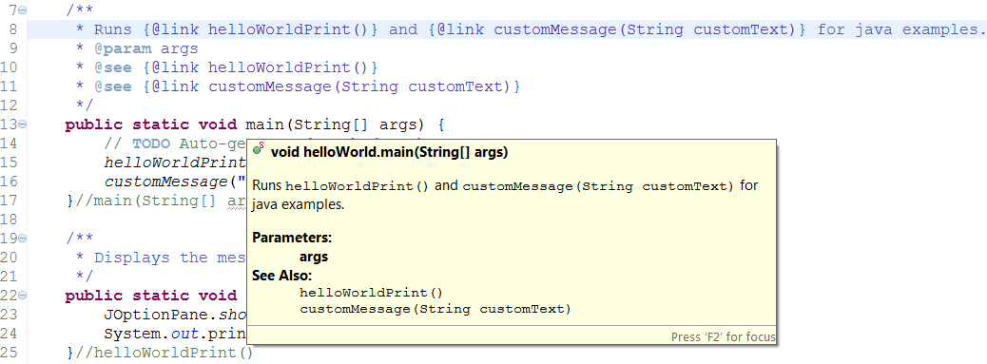

Place the @____ line within the /** */ comment before the class/function you are defining. This will allow a developer to see what a class/function does, without having to look at the code and figure it out.

Example Java Project in subversion at “nac-software-2014\robot\branches\SVN Branches Example Sandbox”.

# Robot Software Design

## Autonomous Command Sequences

## Teleoperated Commands

## Joystick Mappings

# Tool Installation Process

# Opening the Project in Netbeans

File → Open Project → Browse for Trunk or Branches → Project → Open Project

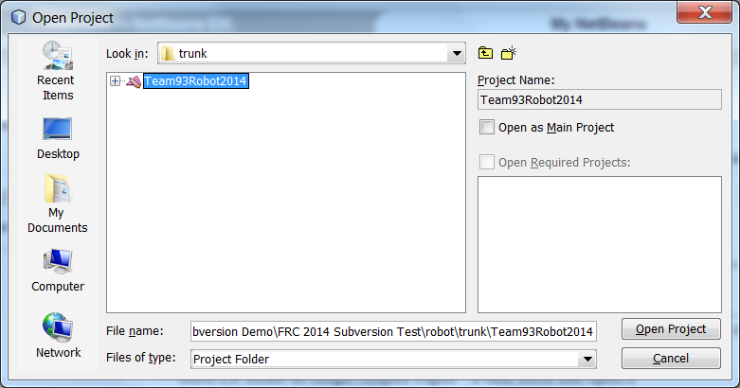

# Opening the Project in Eclipse

File → Import Project → Existing Projects into Workspace

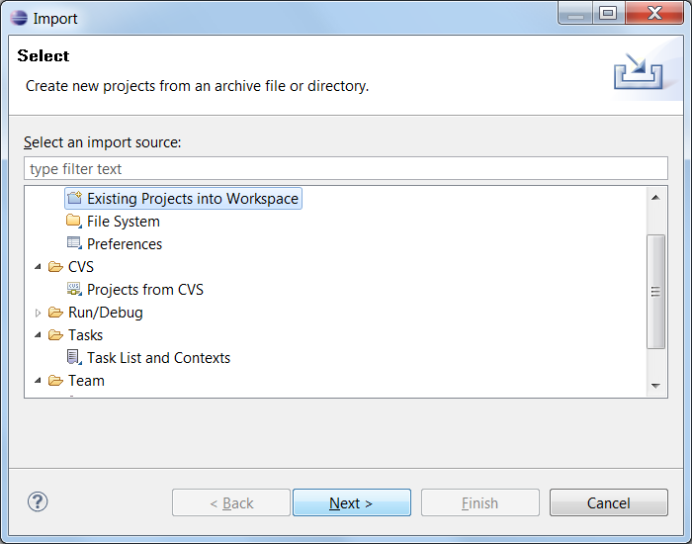

Browse for Project Folder → OK → Finish

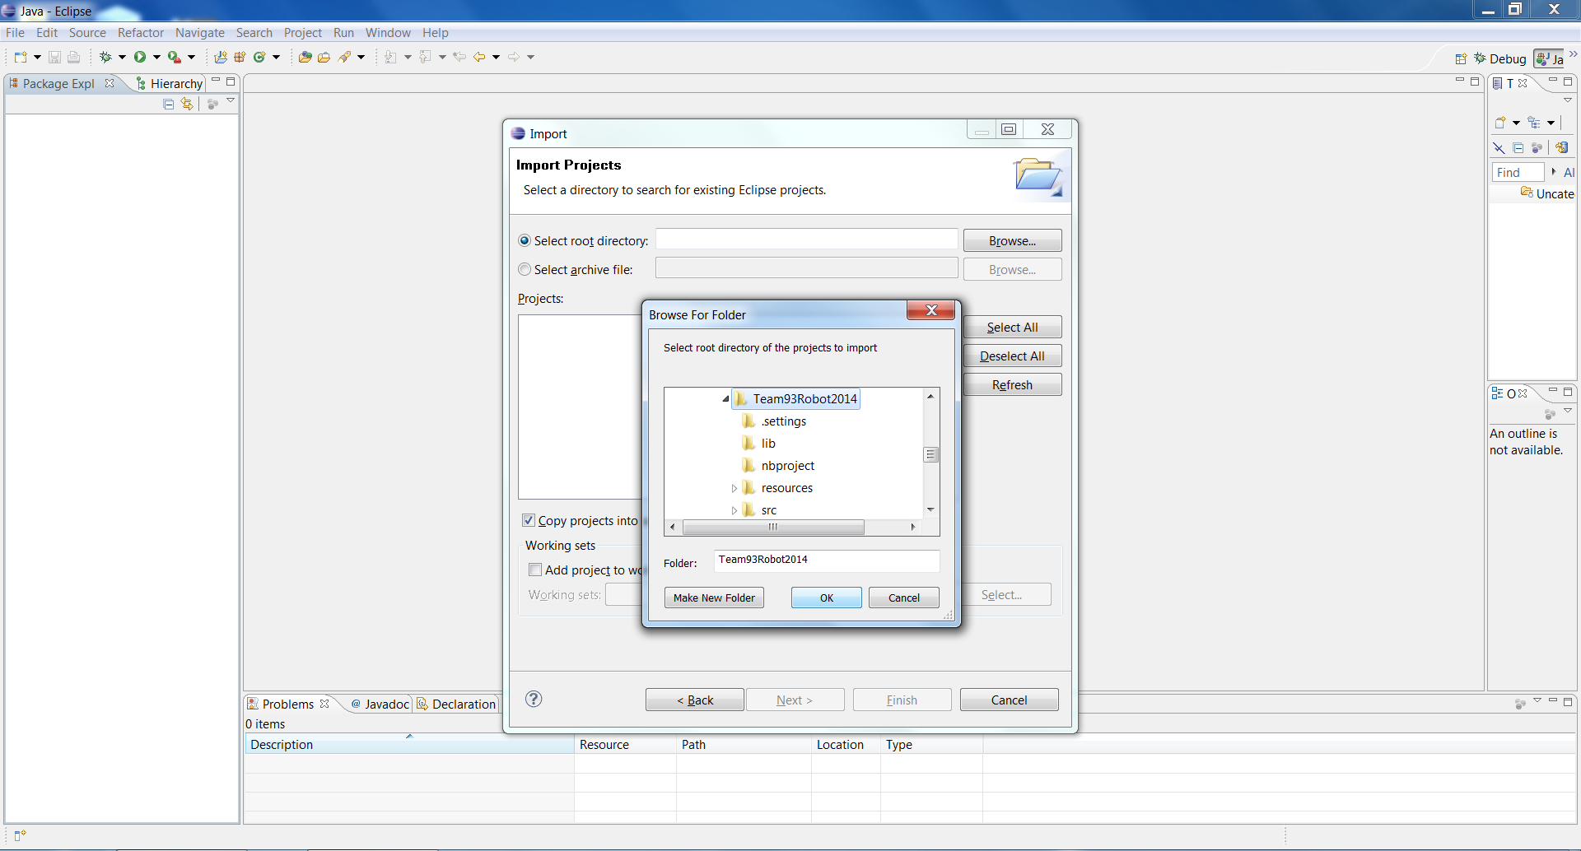

# Computer Setup to Deploy Software to cRIO

1. Statically set IP Address, see Setting Static IP Address
2. Open the FRC Driver Station
3. Connect to the robot
   1. Wireless
      1. Connect to the bridge name for Robot, network names will include “Team 93”
   2. Wired
      1. Simply plug in Ethernet cable, and disable wireless adapter (instructions below) to eliminate any possible connection error
4. Watch the FRC Driver Station, and look for the light next to “Communications” to turn green.
5. Run your project in NetBeans
6. Allow a few minutes for the code to compile, and the cRIO to reboot.
7. Watch the FRC Driver Station and look for all the “Communications” and “Robot Code” lights to turn green.
   1. If you are testing code requiring a controller, make sure you have the plugged into the computer, check settings, if you see a controller plugged in, press buttons to make sure the driver station is receiving input (the text will change color and show a star next to the controller if it is).
8. Press Enable, and test code.
9. Make sure to be able to disable the robot instantly if anything goes wrong.

# Setting IP Address

## Static

1. Right Click on Wireless Connections, click on Network and Sharing Center
2. On the left, click on “Change Adapter Settings”
3. Right Click on the Adapter you want to change the IP of, then click properties

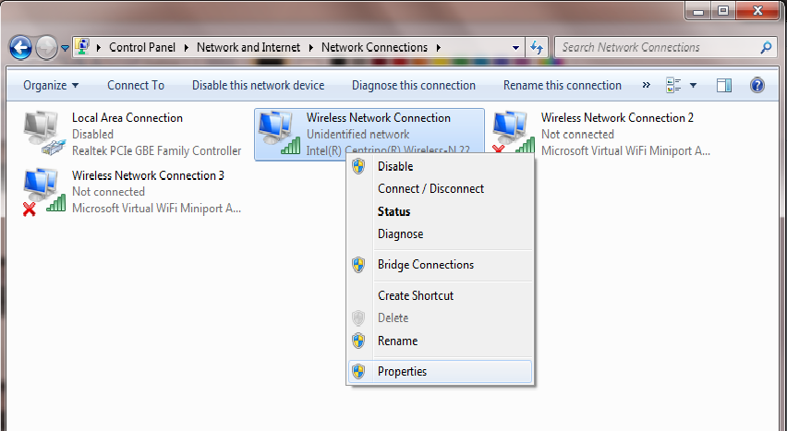

1. Click on TCP/IPv4 (insert picture)
2. Click “Use the Following IP address:” if it isn’t already.
3. Set the IP to 10.0.93.*
   1. Where * is any number between 5-255 (we typically use 5 and 6)
   2. If you get an error claiming that IP’s can’t be the same, change * to a different number within 5-255

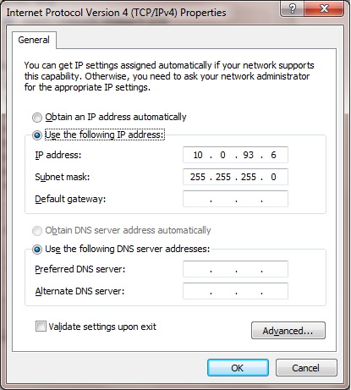

1. Click “OK”
2. Click “Close”
3. Your IP is now set to connect to the robot.

## Automatic

1. Right Click on Wireless Connections, click on Network and Sharing Center
2. On the left, click on “Change Adapter Settings”
3. Right Click on the Adapter you want to change the IP of, then click properties



1. Click on TCP/IPv4 (insert picture)
2. Click “Obtain an IP address automatically” and “Obtain DNS server address automatically”
3. Click “OK”
4. Click “Close”
5. You are now able to connect to the internet.

# Linting Tools

## Tool Execution

## Code Acceptance Criteria

## Automated Linting